Initial meeting(s) Report

(Team Members): Cody Uhi, Derryck Dunn, Daniel De La O, Stephen Kendall, Spencer Sundrud

* Contact information (including all students and coach)

|  |  |  |
| --- | --- | --- |
| Name | Phone | Email |
| Stephen Kendall | <REDACTED> | <REDACTED> |
| Derryck Dunn | <REDACTED> | <REDACTED> |
| Spencer Sundrud | <REDACTED> | <REDACTED> |
| Cody Uhi | <REDACTED> | <REDACTED> |
| Daniel De La O | <REDACTED> | <REDACTED> |

* Team Initial Organizational Chart (copy and paste in an actual chart that includes project manager and customer liaison)

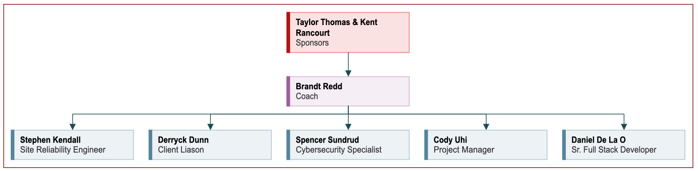

* Weekly meetings schedule.
  + Coach (1 hour weekly meeting expected):
    1. (TBD. Coach was emailed to schedule a good time).
  + Team Meetings (3+ hours expected):
    1. Monday’s at 9 AM
* Project Name (and codename if needed):_________________________________
  + Project Sombrero?
  + Re: Kashti
  + Kashtastic
  + Kashisoft
  + Micro-Kash
  + Kashti re-vamp
* Who is setting up meeting with sponsor?
  + Derryck Dunn
* Describe communication technology plan (briefly)
  + Use Teams as the main communication method (chat). Use Teams to track tasks by assigning tasks to individuals within the group.
* Describe project scope (briefly)
  + Re-design and re-implement Kashti from the ground up
  + Make sure it is Brigade 2.0 compatible
  + Add new project + provide event management features
  + Work with Brigade project leads who are currently building out the Brigade 2.0 API
  + **Along the way...**
    - Authenticate users with a third-party identity and providers using OpenID connect
    - Develop JavaScript SDK for the new Brigade API
    - Package Kashti for easy installation on Kubernetes via the Helm package manager